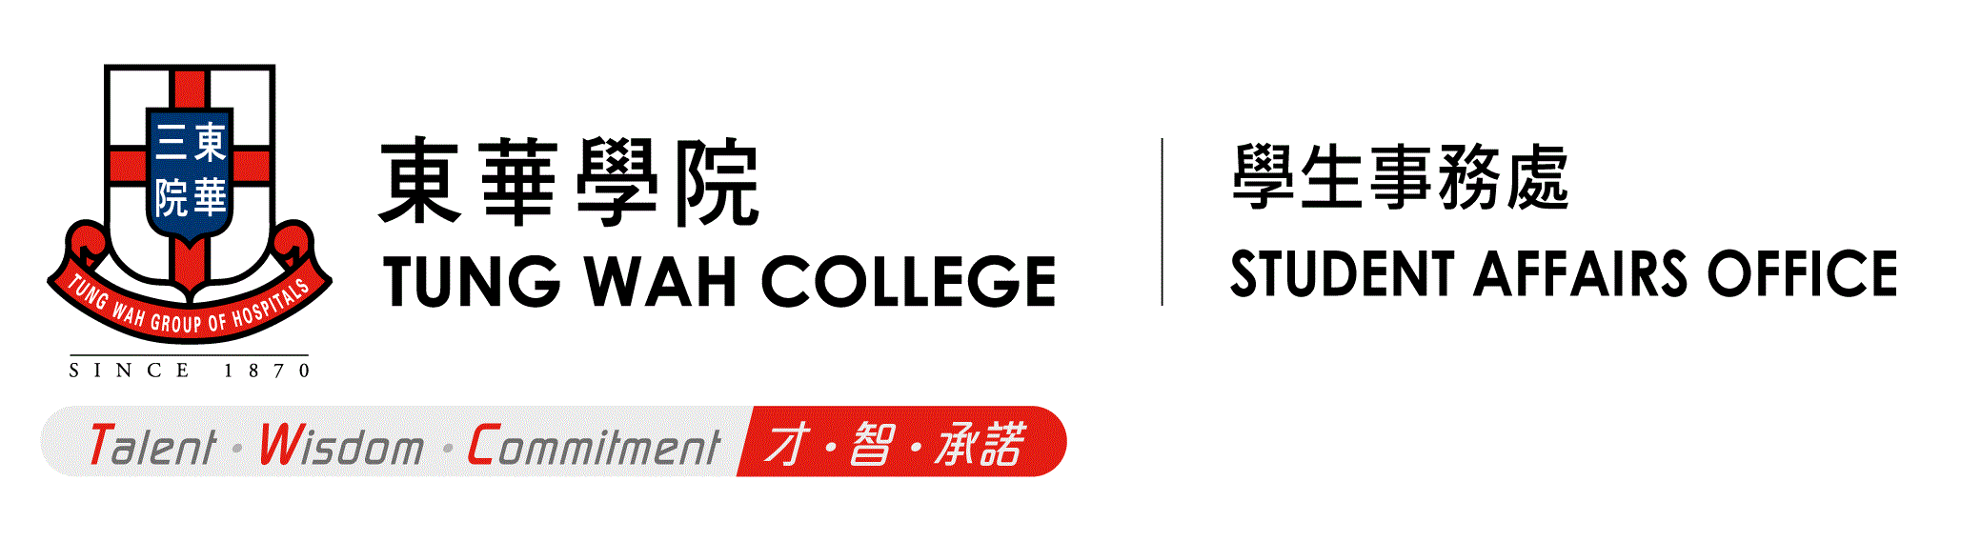

Form/SAO 44/202311

**TUNG WAH COLLEGE**

**OUTSTANDING STUDENT AWARDS**

**APPLICATION FORM**

* Please read the “Guidance Notes for Applicants” before completing this application form.
* Please send your completed application form and any other proof of documents to Student Affairs Office’s email at [sao@twc.edu.hk](mailto:sao@twc.edu.hk) before the deadline**.**

1. **Personal Information**

|  |  |
| --- | --- |
| Name in English |  |
| Name in Chinese  (If applicable) |  |
| Student Number |  |
| Telephone Number |  |
| Email |  |

1. **Education and Academic Record**

|  |  |  |  |  |
| --- | --- | --- | --- | --- |
| Academic Unit | 󠄶 [School of Arts and Humanities](https://www.twc.edu.hk/en/Academic_Units/ARH)  󠄶 School of Management | | 󠄶 School of Medical and Health Sciences  󠄶 School of Nursing | |
| Programme |  | | | |
| Current Year of Study |  | Expected Year of Graduation | |  |
| cGPA |  | | | |
| sGPA (for the last two consecutive semesters) | Semester 1: _____________(AY / )  Semester 2: _____________(AY / ) | | | |

1. **Record of Services and Contributions to Fellow Students, and/or Tung Wah College**

*(Maximum FIVE items and please provide proof of documents)*

|  |  |  |  |  |
| --- | --- | --- | --- | --- |
|  | Name of Organisation | Position/ Achievements | Description | Service Period  (month/year) |
| e.g. | TWCSU | President | * Organised ocamp to 100 new students in summer 2016 * Arranged various activities (e.g. welfare week, Xmas Party) to strengthen bonding among students | 11/2015-11/2016 |
| 1 |  |  |  |  |
| 2 |  |  |  |  |
| 3 |  |  |  |  |
| 4 |  |  |  |  |
| 5 |  |  |  |  |

1. **Record of Services and Contributions to any Organisation and/or the Community**

*(Maximum FIVE items not mentioned above and please provide proof of documents)*

|  |  |  |  |  |  |
| --- | --- | --- | --- | --- | --- |
|  | Name | Position / Achievements | Description | Service Period  (month/year) | Total Hours |
| e.g. | “Equality for Tomorrow” – Learning Camp for ethnic minority students, Scout Association of Hong Kong | Public Relations Officer | * Held a 2-day learning camp for 45 ethnic minority secondary school students in April 2018 * Organised a visit to the Equal Opportunities Commission during the camp to introduce anti-discrimination laws to ethnic minority students | 09/2018 | 30 hours |
| 1 |  |  |  |  |  |
| 2 |  |  |  |  |  |
| 3 |  |  |  |  |  |
| 4 |  |  |  |  |  |
| 5 |  |  |  |  |  |

1. **Record of Extra-curricular Activities, Prizes and/or Awards**

*(Maximum FIVE items not mentioned above and please provide proof of documents)*

|  |  |  |  |
| --- | --- | --- | --- |
|  | Name | Position/  Achievements | Period  (month/year) |
| e.g. | Hong Kong Social Enterprise Challenge | Semi-finalist | 10/2018-01/2019 |
| 1 |  |  |  |
| 2 |  |  |  |
| 3 |  |  |  |
| 4 |  |  |  |
| 5 |  |  |  |

1. **Please share your experience or expertise/ persistence to meet challenges, while demonstrating competency of effective problem solving.**

*(Please limit your answer to 300 words, you may answer in either English or Chinese. Use a separate sheet if necessary.)*

|  |
| --- |
|  |

1. **Referee(s):**

Please provide at least ONE referee who could provide additional information about you (including supporting documents).

|  |  |
| --- | --- |
| Name: | Name of Organisation: |
| Relationship with Referee: | Post: |
| Telephone No.: | Email: |

|  |  |
| --- | --- |
| Name: | Name of Organisation: |
| Relationship with Referee: | Post: |
| Telephone No.: | Email: |

1. **Declaration**

I confirm that all information contained in this application is true and accurate. I also understand and accept that the information given is used for award selection only and will be destroyed three years after the application deadline. Only personal information of the award recipients will be retained by the Tung Wah College for future correspondence.

|  |  |
| --- | --- |
| Signature: | Date: |

- End -